**EDUNET FOUNDATION - Class Exercise Notebook**

**LAB 1 – Create a new bot project**

# Create SAP Conversational AI account

Go to <https://cai.tools.sap/>, and click Sign Up in the upper-right corner.

Follow the instructions for creating an account.

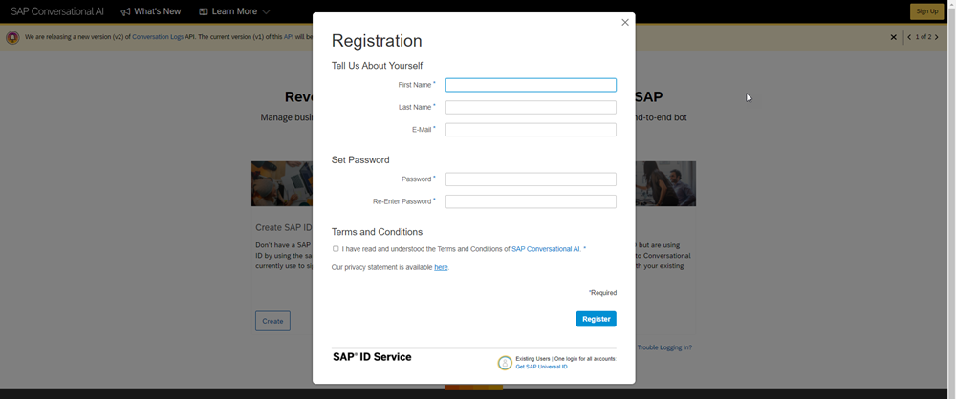

You will get an email with a link to validate your account.

# Create new bot project

Do one of the following:

If you just validated your account by clicking the link in your email, click Start with a Template.

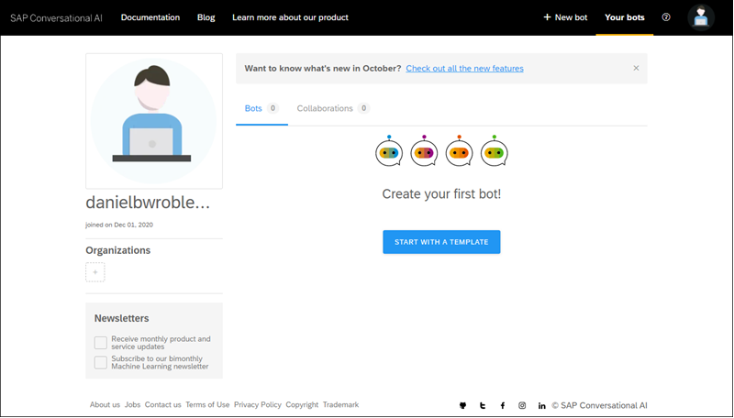

If you are returning:

* Go to your home page by opening the URL <https://cai.tools.sap/> and sign in.
* Click New Bot.

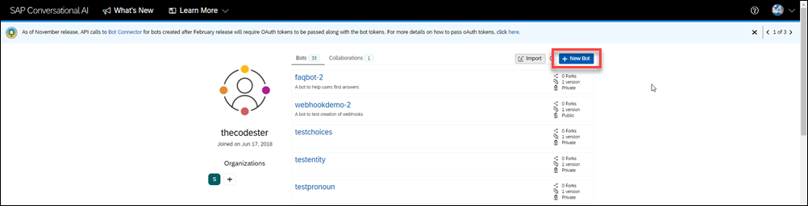

Fill in the following:

* Select **Perform Actions**.
* For the predefined skills, choose Greetings.
* In the Create your bot section, enter the following:

| **Field Name** | **Value** |
| --- | --- |
| Bot name | my-first-bot |
| Description | A bot that likes to tell jokes and have a little fun |

* For **Data Policy**, select the following:
* Non-personal.
* Store.
* Non-vulnerable.
* For **Bot visibility**, select **Public**.

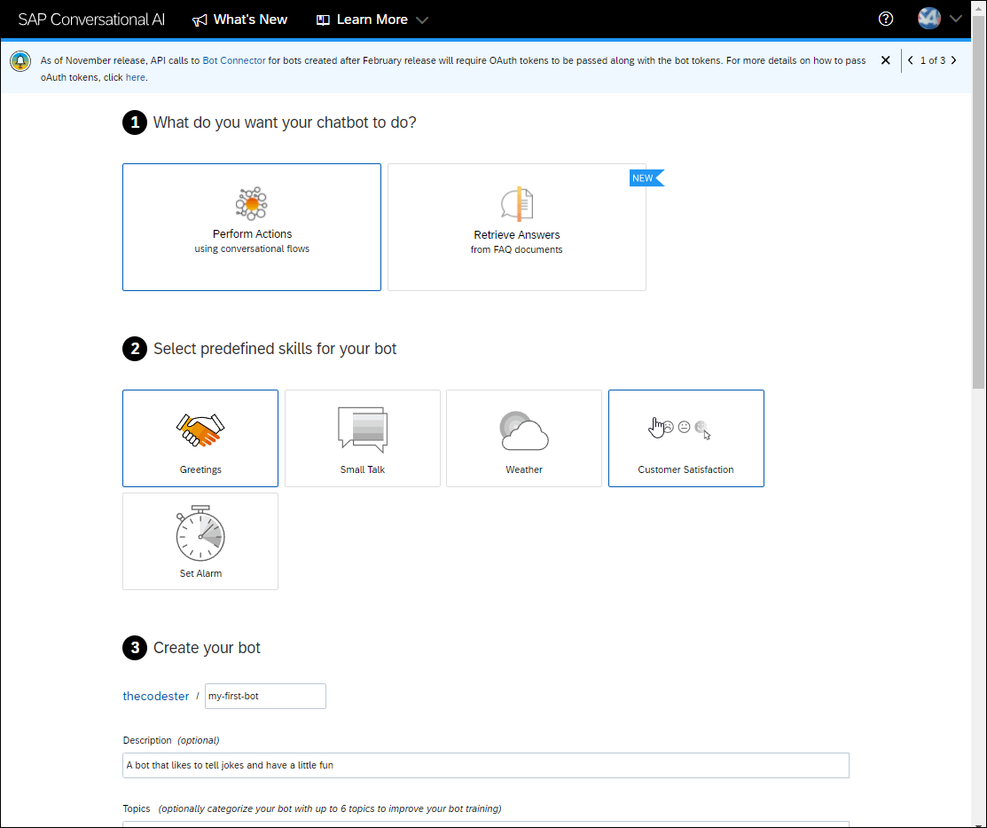

Click **Create a bot**.

# The 4 stages of a bot's life

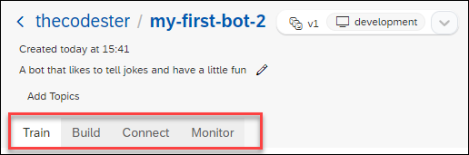

# Fork intent

1. Go to the **Train** tab.
2. In the **Search** box, enter joke, and press **Search**.

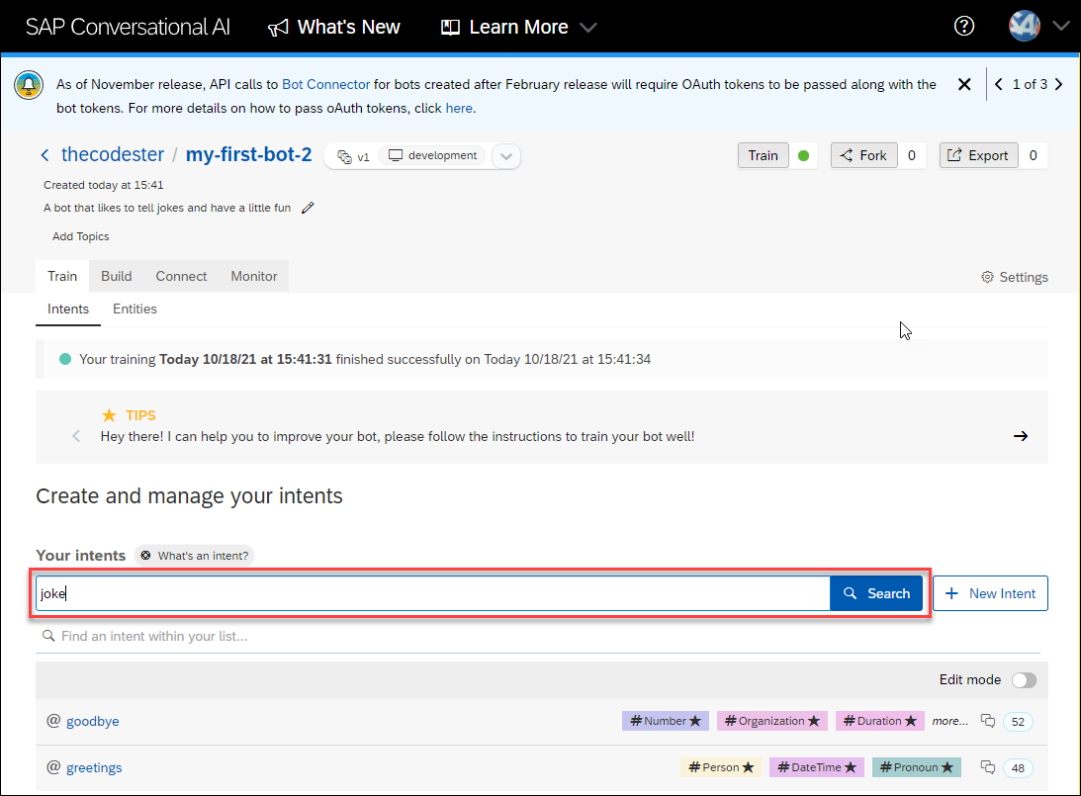

You will get a list of intents to fork.

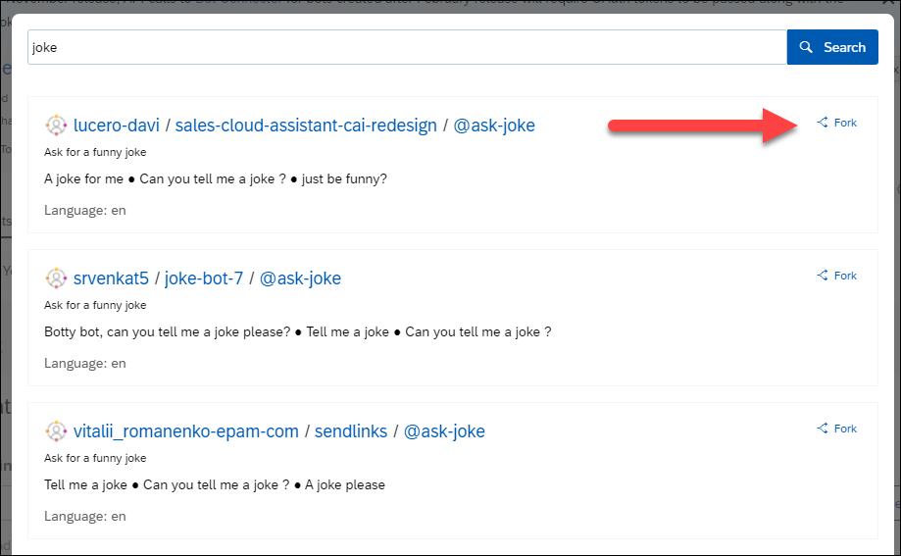

3. Click **Fork** for the first @ask-joke intent.

There are many existing intents and the choices are always changing.

4. Explore the intent by clicking on it.

In the intent we forked, there are 2 expressions to discern if someone wants to be told a joke. In yours, you may receive more expressions.

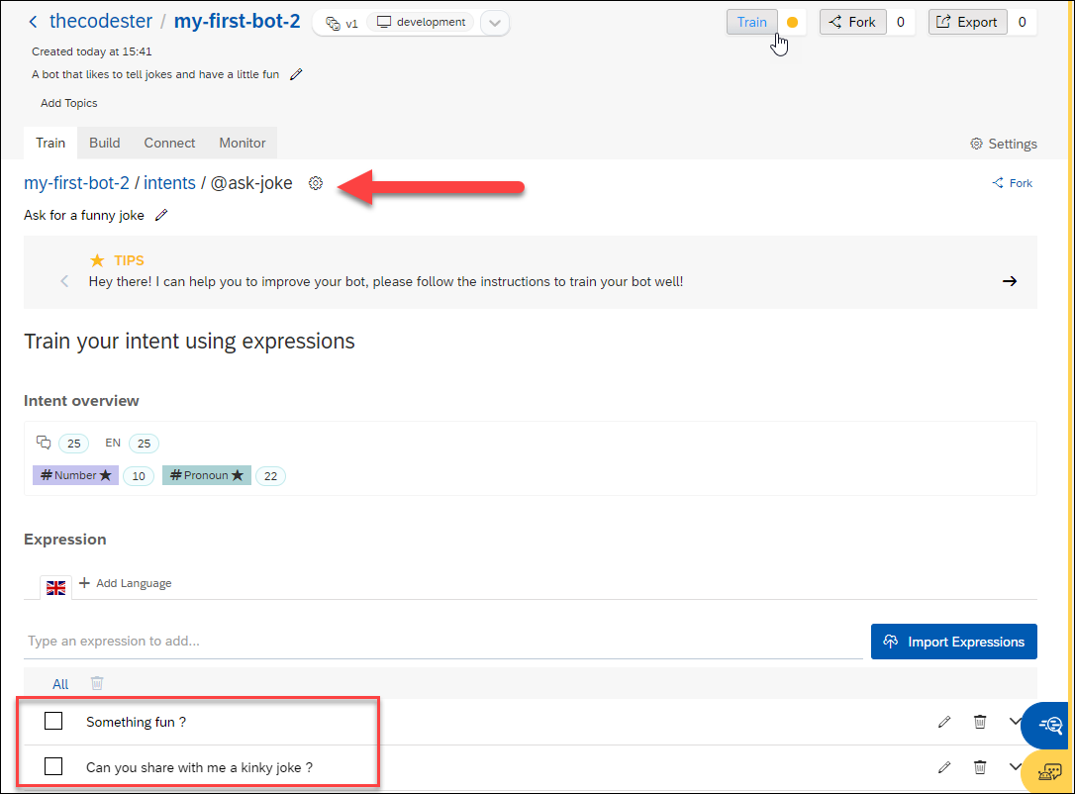

# Create new intents

You will be able to reuse many, many intents created by others. But there are times you will want to create your own.

1. Click the **Train** tab.
2. Create an intent for recognizing good reactions to jokes.
   * Click **Create**.

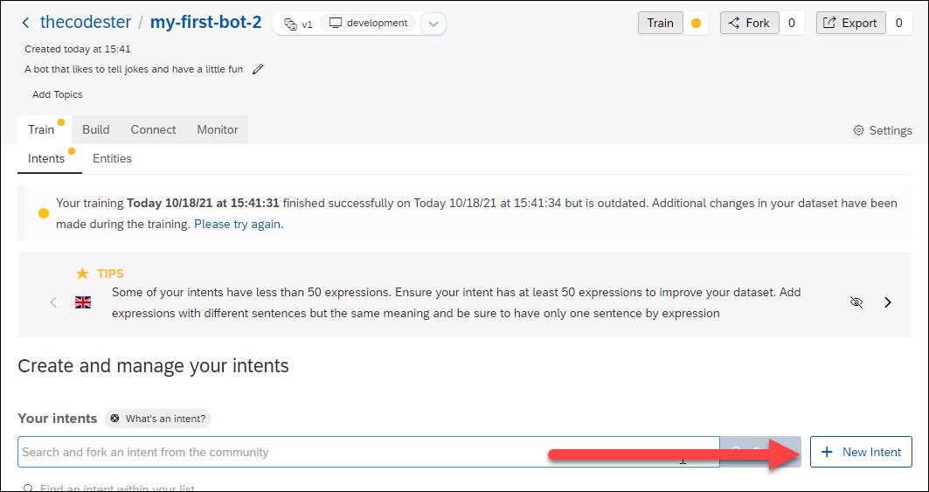

* For the name of the intent, enter **laughs**.
* For the description, enter **A natural reaction to our awesome jokes**.

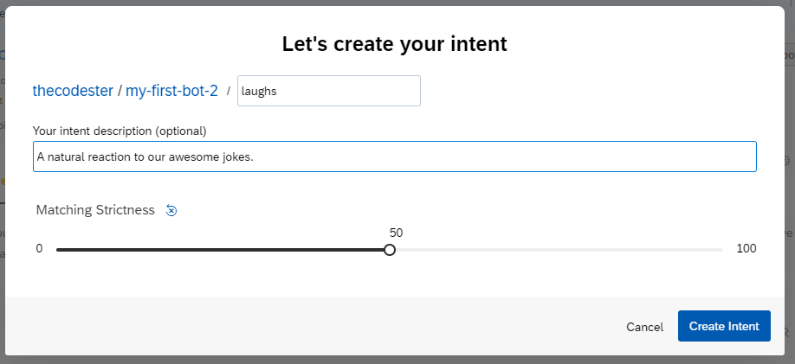

* Click Create Intent.

3. Create a second intent, this time for bad reactions to jokes.

* + Click **Create**.
  + For the name of the intent, enter **lame**.
  + For the description, enter **You can’t succeed every time**.
  + Click **Create Intent**.

# Add expressions

1. Click on the @laughs intent.
2. In the expression field, enter a sentence you want your bot to understand, then press **Enter**.

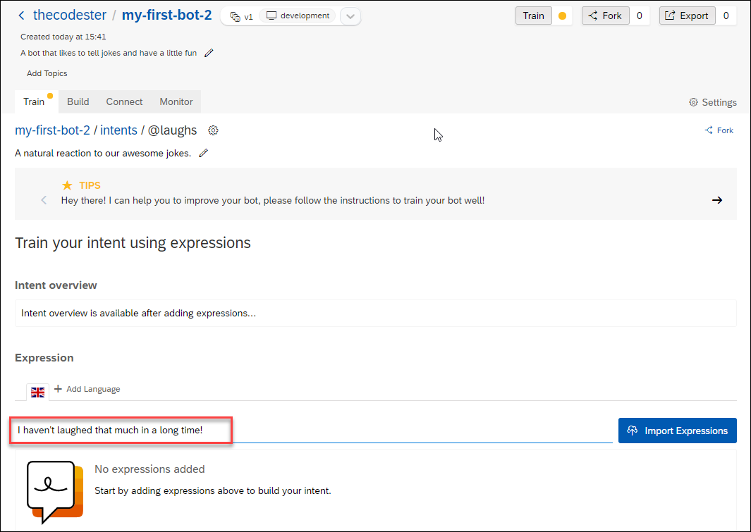

# Test bot

We want to now test to see if the bot can detect when a user says something matching the intent we created.

1. Click the **Train** button at the top-right, so that the bot trains itself based on the latest intents and expressions (sometimes referred as your dataset).

The button indicates the current status of training: Yellow is out of date, blue is training, green is up to date..

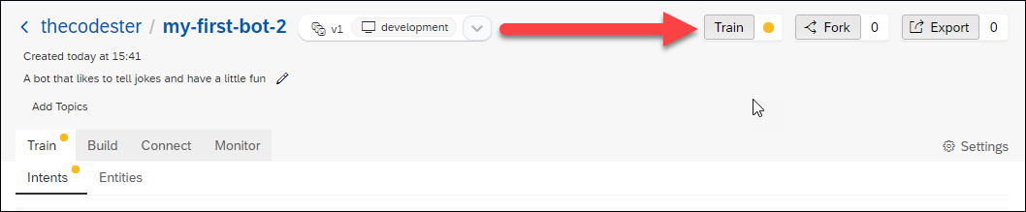

By default, your bot does not train itself but you must click Train for it to understand the latest intents and expressions.

You can change the setting so the bot automatically trains itself at **Settings > Version > (current version dropdown)**, and scroll down to .

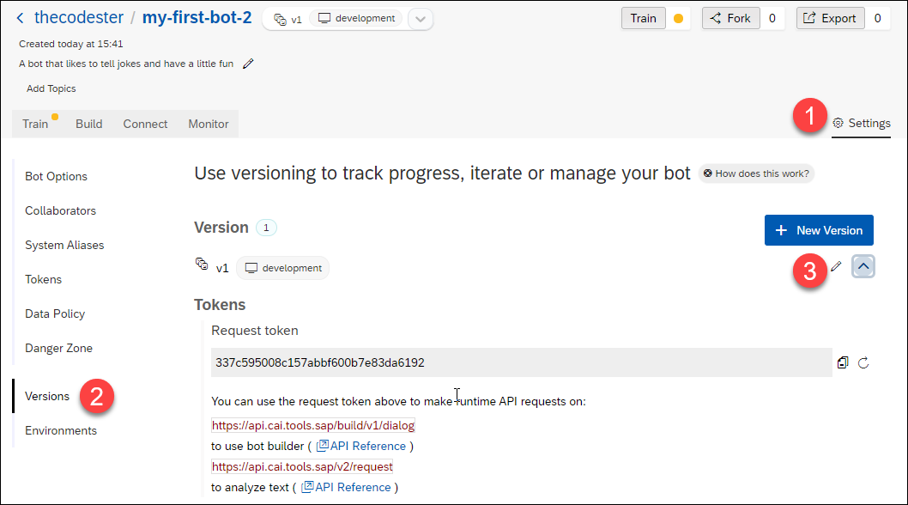

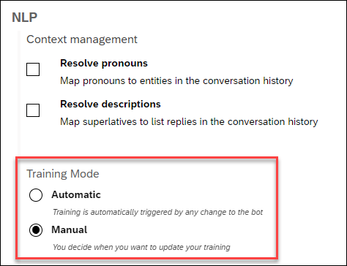

1. **At the bottom of the panel, open the Expression Analysis tab**

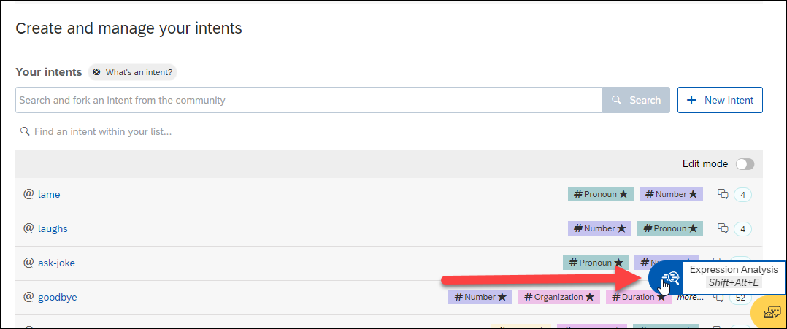

1. **Enter something that you think should match the intent, like:**

Botty bot, can you tell me a joke please?

If the intent is successfully trained, the test will show that the bot recognized the intent (as well as entities within the expression).

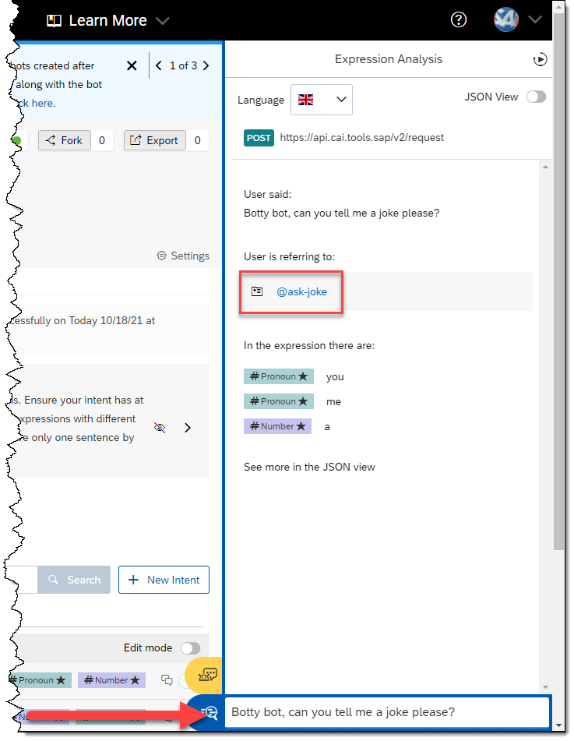

If the bot did not recognize the intent (or selected the wrong intent), you will need to train your bot some more by adding additional expressions (Step 6).

# Manage conversation flow with skills

Now that your bot knows how to understand people who talk to it, it’s time to give your robot some skills.

Open the **Build** tab.

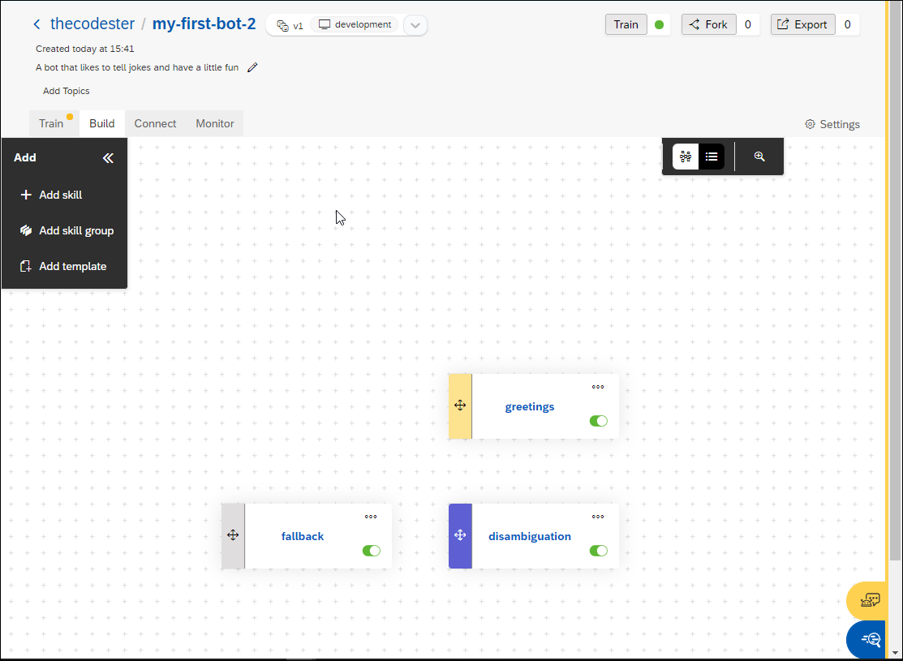

Inside, you’ll find the **Bot Builder**, which helps you construct the conversation flow of your bot.

### What is a skill?

Each skill represents one thing that your bot knows how to do. Your skill can be complicated (e.g., manage payment by credit card) or quite simple (e.g., answer a basic question).

Just like intents, you can create a skill from scratch or inherit skills from other bots you’ve created or from other people’s bots.

In our project, choose the predefined skill **Greetings**.

The **Greetings** skill – like all skills – has 4 tabs:

* **README.md:** A description of the purpose of your skill
* **Triggers:** The conditions that must occur – generally the intents that the user must express – for the skill to be executed
* **Requirements:** Information that must be collected in order for the skill to be executed
* **Actions:** The action to take (basically, this is the skill)

If you navigate through the tabs, you’ll see that the **Greetings** skill is structured as follows:

* It is triggered if either the intent @greetings or @goodbye is matched.
* It has no requirements because it does not need to collect additional information. That means that it will execute actions directly after being triggered.
* It has two possible actions: If the @greetings intent is matched, it sends a random welcoming message chosen from a list. If the @goodbye intent is matched, it does the same thing, but picks the message from a different list.

# Create new skill

Now let’s build a skill to tell a joke.

1. Go back to the **Build** tab – where you see the canvas.
2. Click **Add skill**

There are several types of skills:

* **Business** skills reflect the core purpose of your bot.
* **Floating** skills complement your bot’s core business skills (for example, small talk).
* The **Initialize** skill (there can only be one in a chatbot) is triggered when the conversation with the user starts.

1. Call your skill tell-me-a-joke, set the type as Business, and click Add.

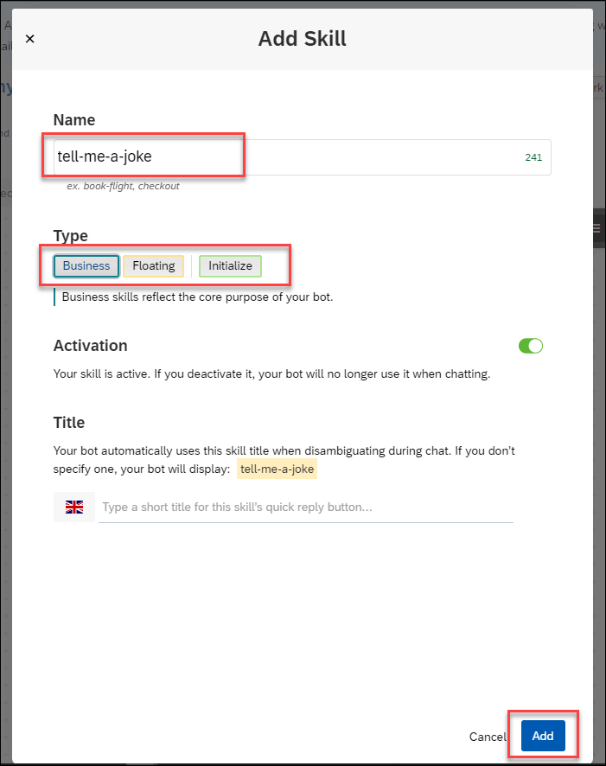

1. Click the new tell-me-a-joke skill, and open the Triggers tab.
2. Add 3 If statements, one for each of the @ask-joke, @laugh, and @lame intents.
   * Click in the empty space right after If, select the @ask-joke intent, and then click **Save**.

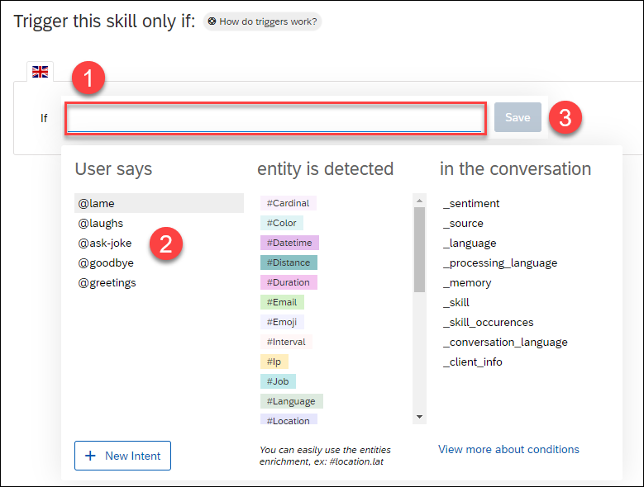

* Click on the **+** sign – **Add a new list of conditions** – and repeat the above for @laughs and @lame intents.
* Change the logical conditions to Or between each If statement, simply by clicking And.

It should now look like this:

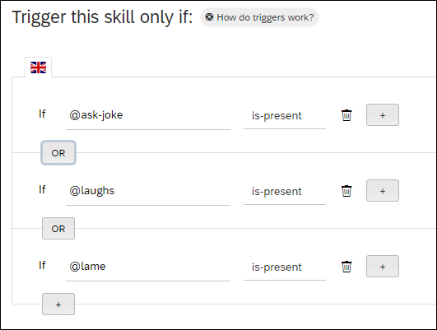

1. Go to the Actions tab.
2. Click New Action Group, then Add Condition.
3. After the If, select the @ask-joke intent, and click Save.
4. Click Choose Message Type, choose the Text format, and type in a really good joke, like:

I just flew into town, and boy are my arms tired.

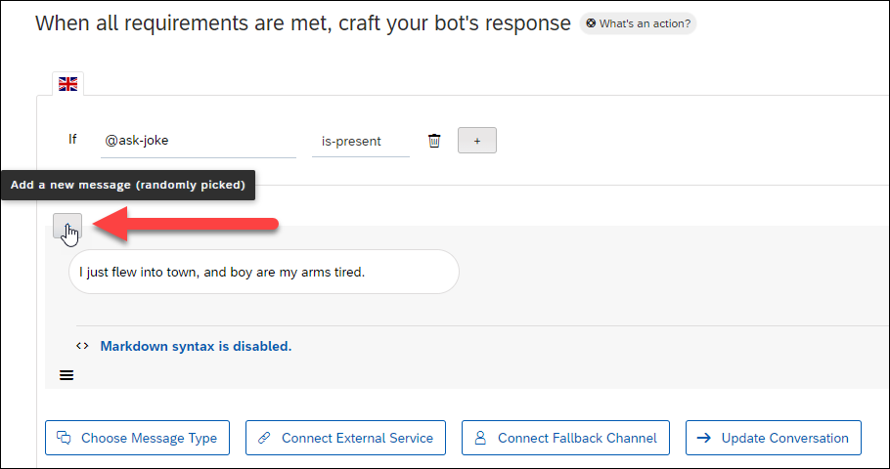

You can also set a delay (optional) between two messages, up to 5 seconds. This might be useful when the messages your bot sends are quite long and need time to be read by the user.

1. Click Save.

# Test by chatting with bot

Before releasing your bot to your audience, chat with it in real situation. This will help show you how the bot will behave in a “real” conversation.

Double-check if there are any errors in the conversation flow (e.g., bad answers, fallback errors, weird behavior) and correct them before sending the bot out.

Chat with your bot as often as you can while you build it, which will make it easier to find problems.

Click on the bottom-right yellow button Chat Preview and start sending messages. Use the clear icon   at the top of the panel to refresh the chat.

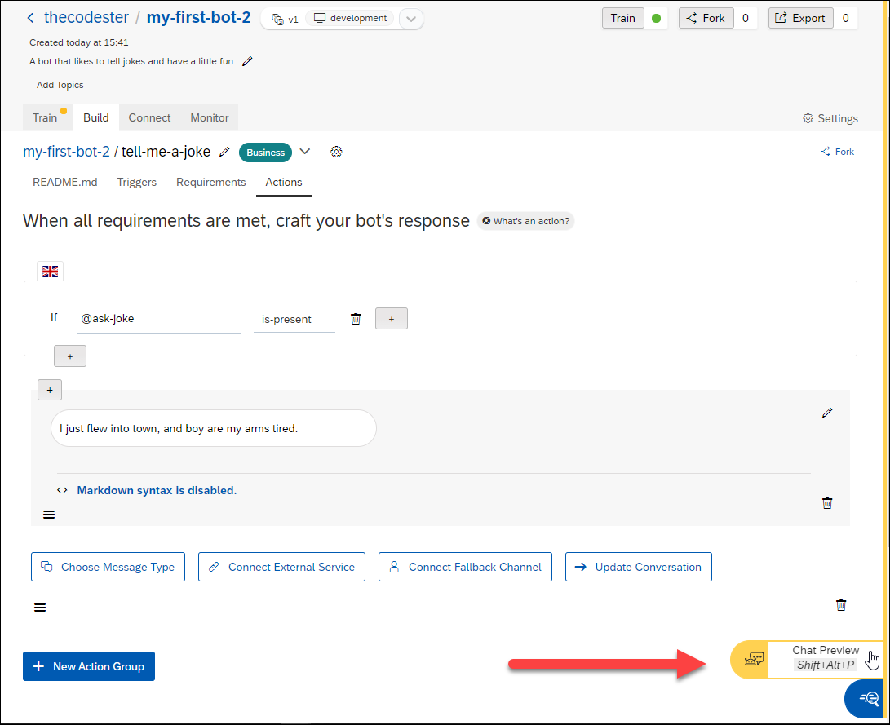

* If you say **Tell me a joke**, the bot will tell you a joke.
* Try other phrases and see how the bot responds. If the bot does not respond properly, then try improving your intent with additional expressions.

